**Name:** Chillara V L N S Pavana Vamsi

**Reg.no:** 21BCE5095

**Date:** 29/12/2022

**Faculty:** M Sivagami

## L21_L22_Lab2 Exercises

1. Develop a child process to display the hello message, observe the output and give justification of the output.
   1. 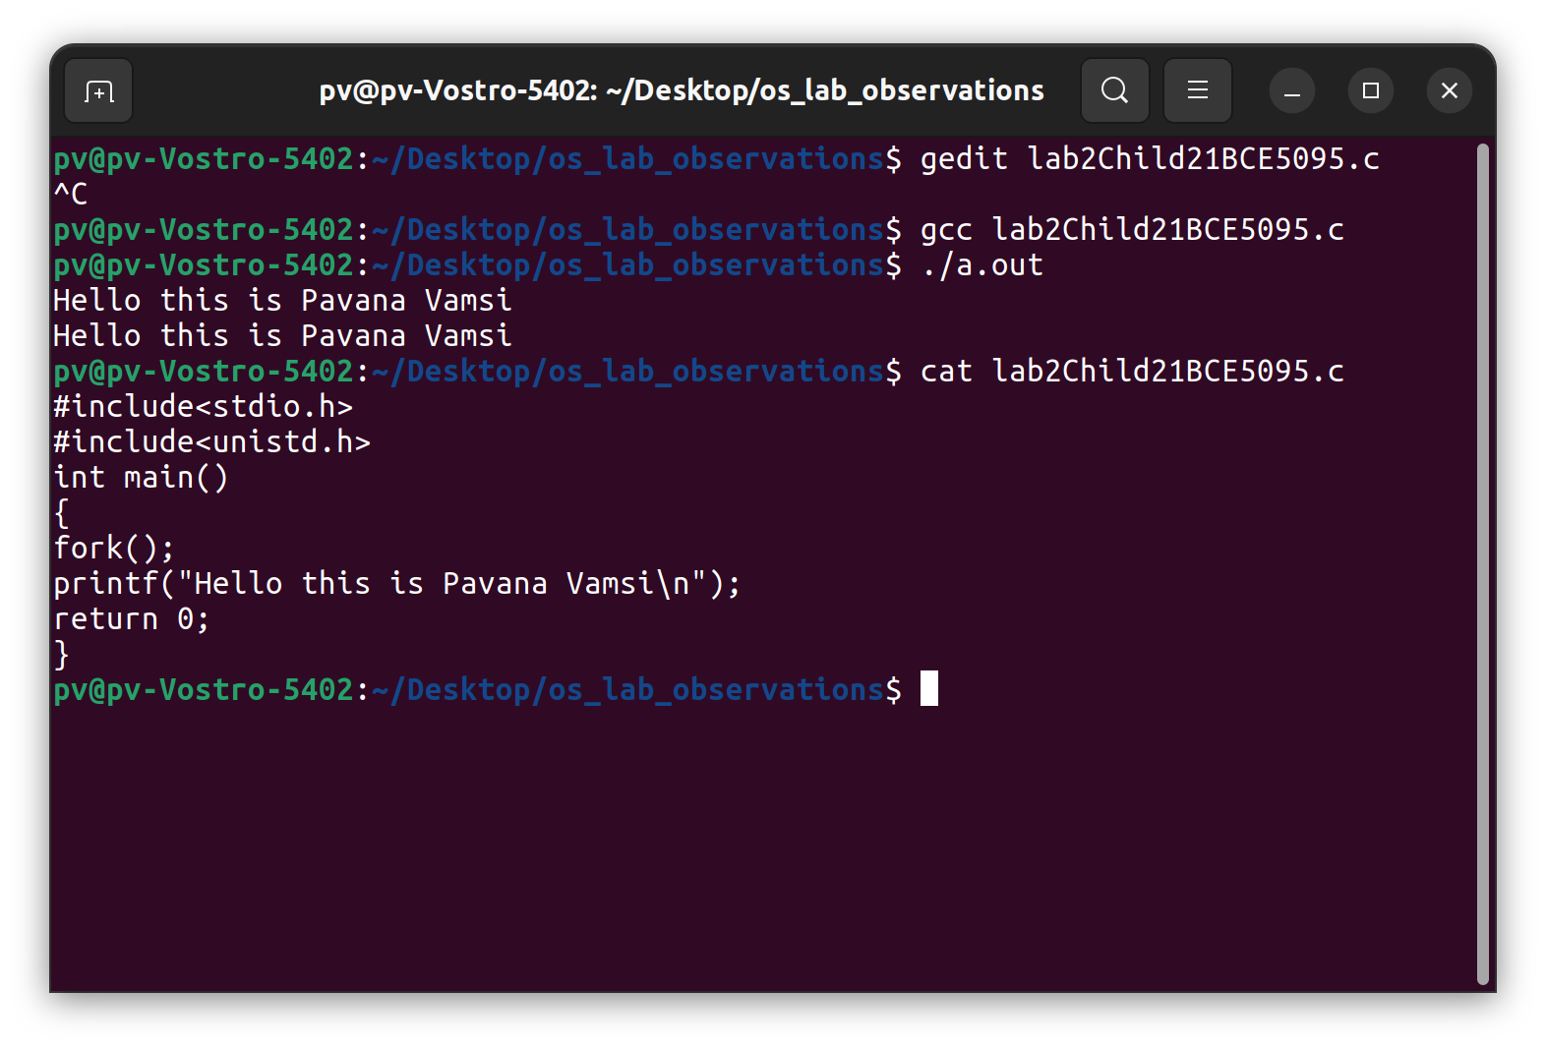When we run the program with one child process, we can see the output as two printf without using any loop. Here the child process created prints the output and other output is print by actual parent that is main ().
   2. 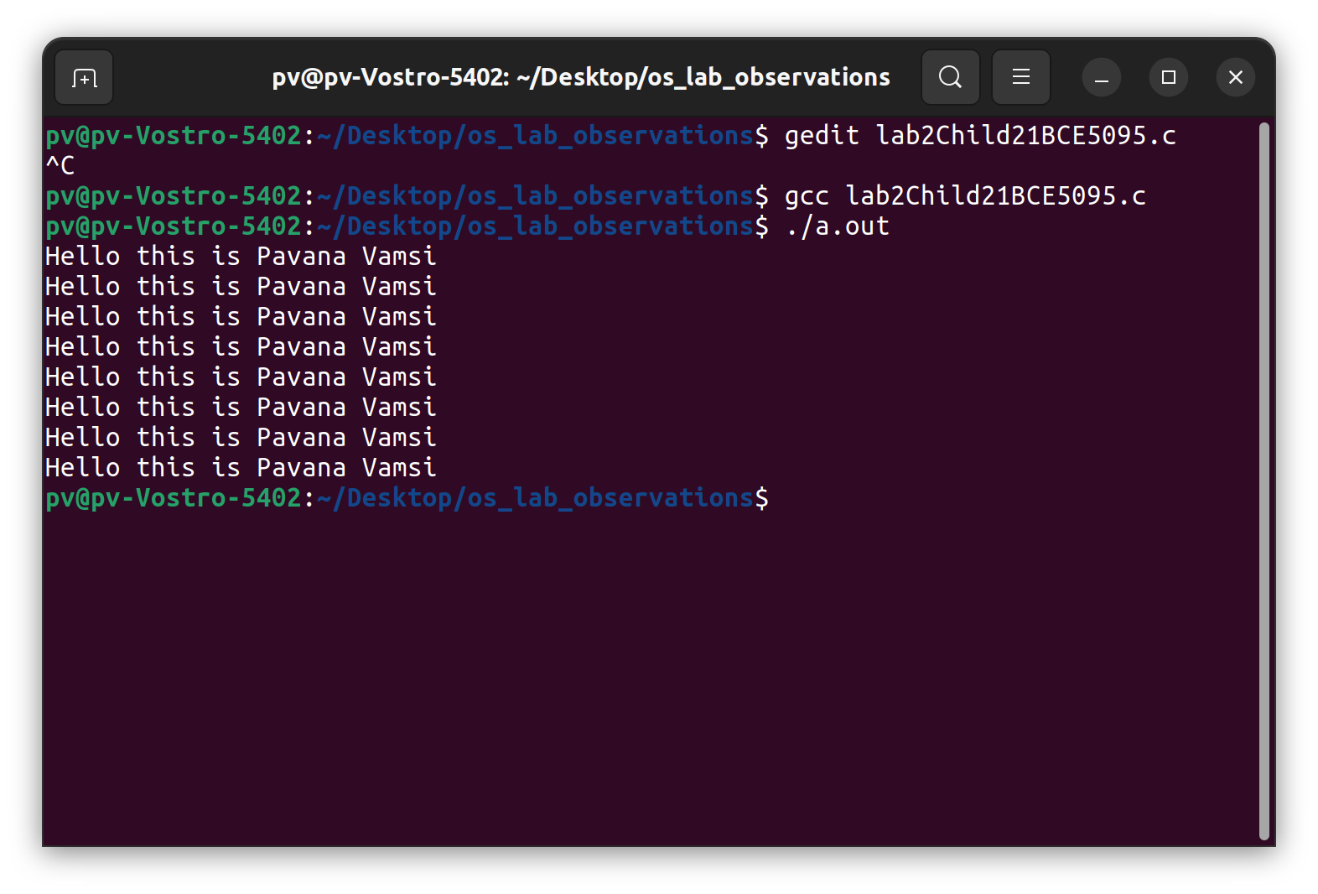If we use more fork () continusly more child process will be created like if we create n fork at a time then we can observe 2n hello will be printed in the output screen.
2. Develop a child process to display the numbers 500 to 1000 and parent process to display from 1 to 500.Observe the output and give justification for the same.

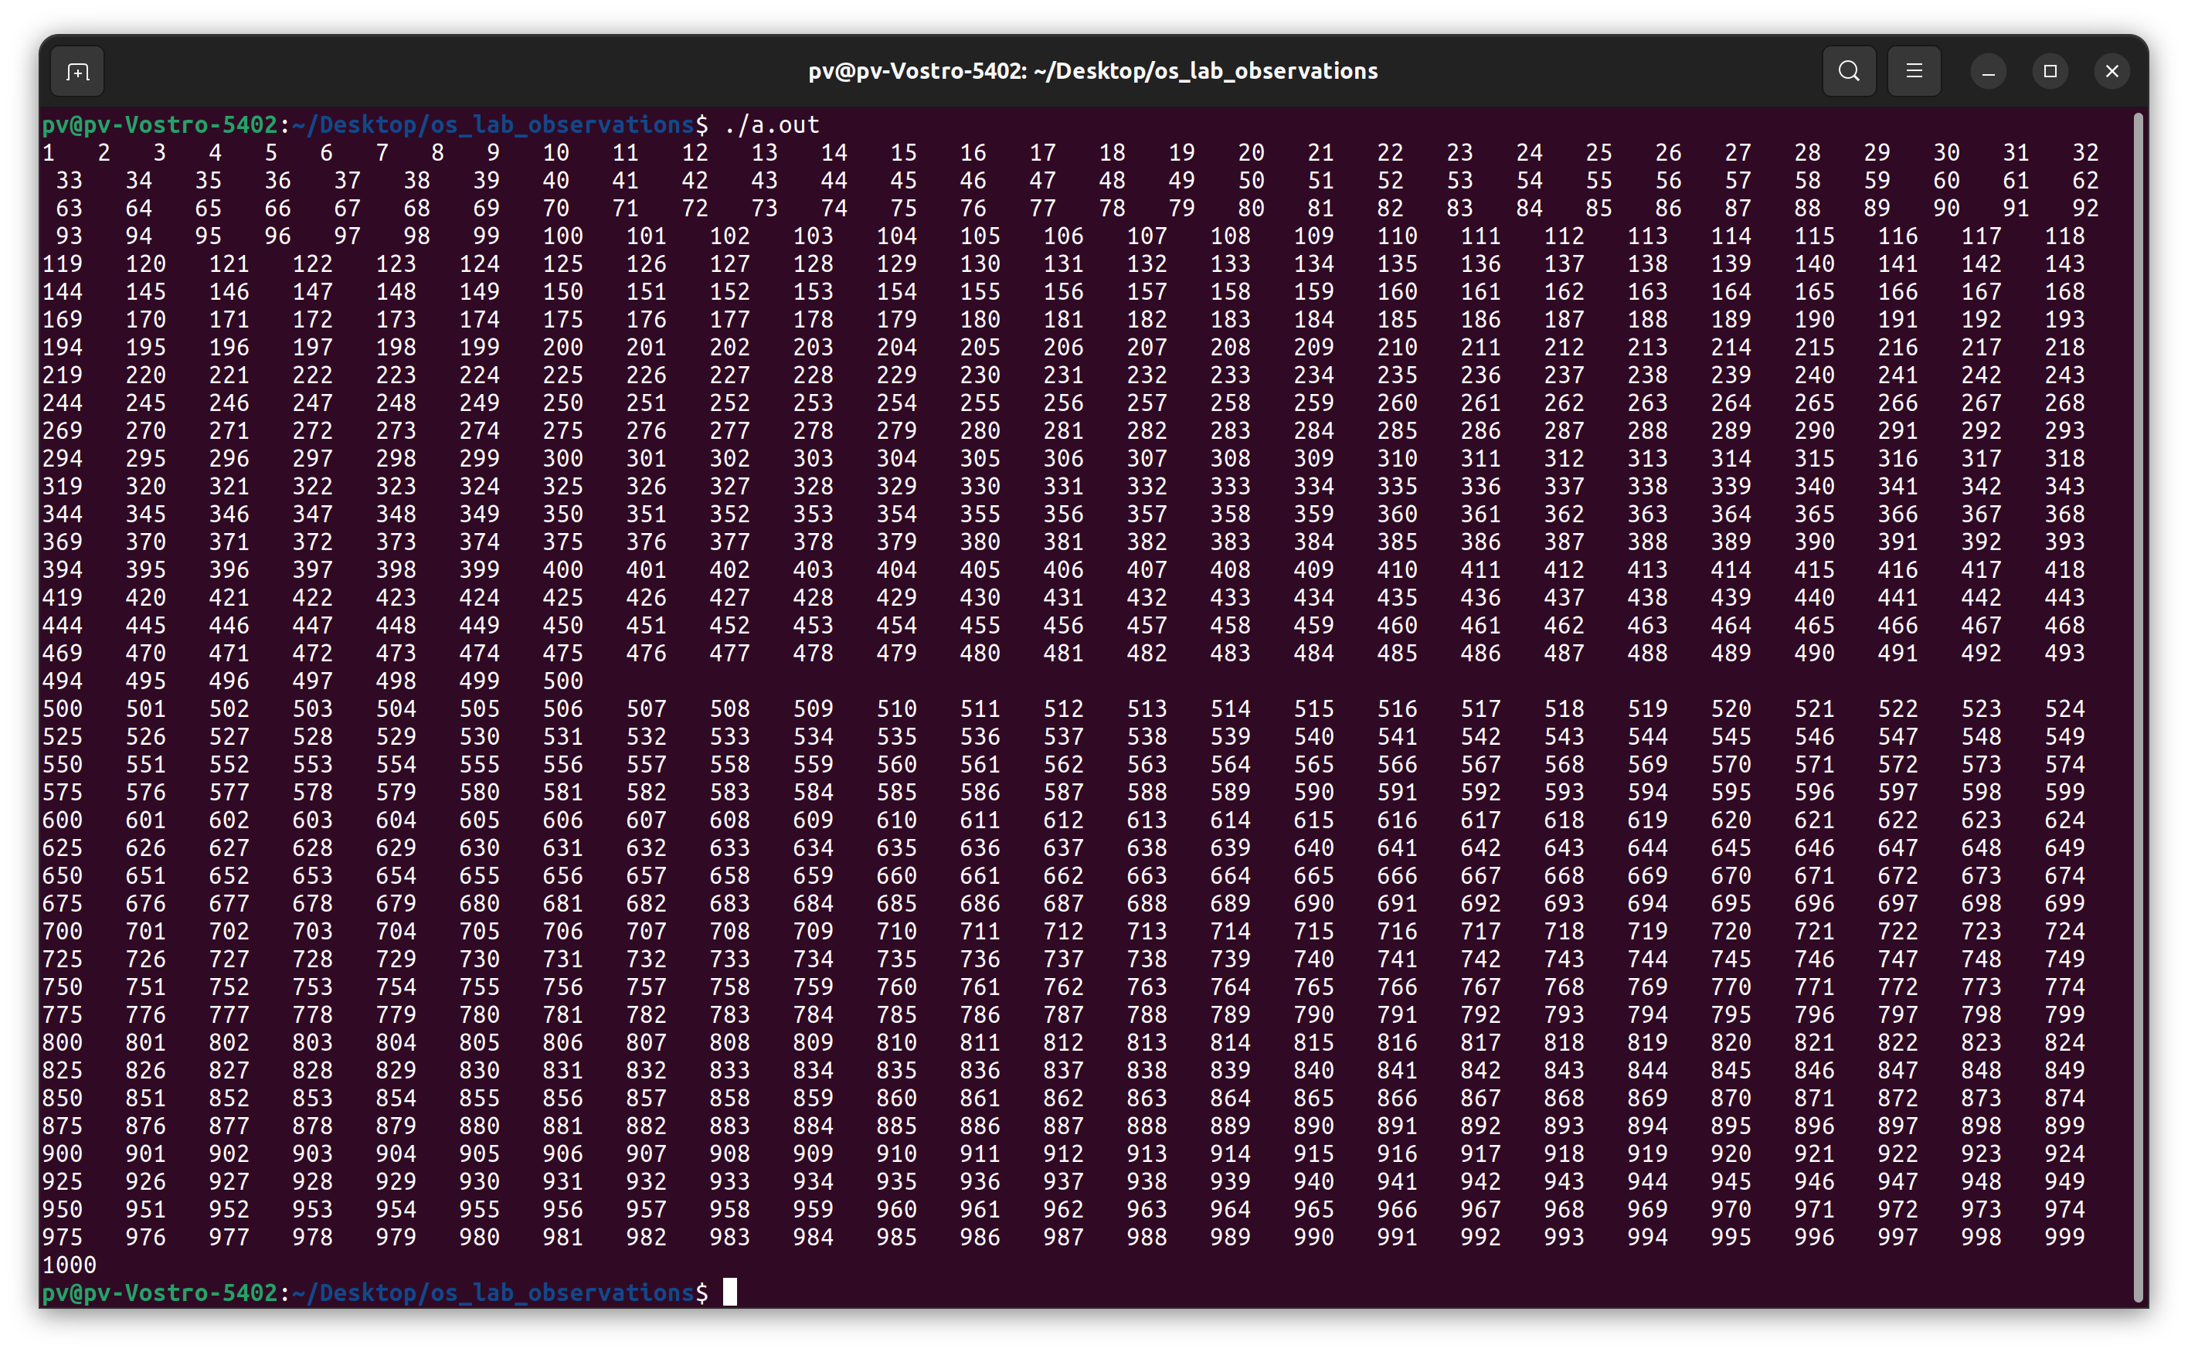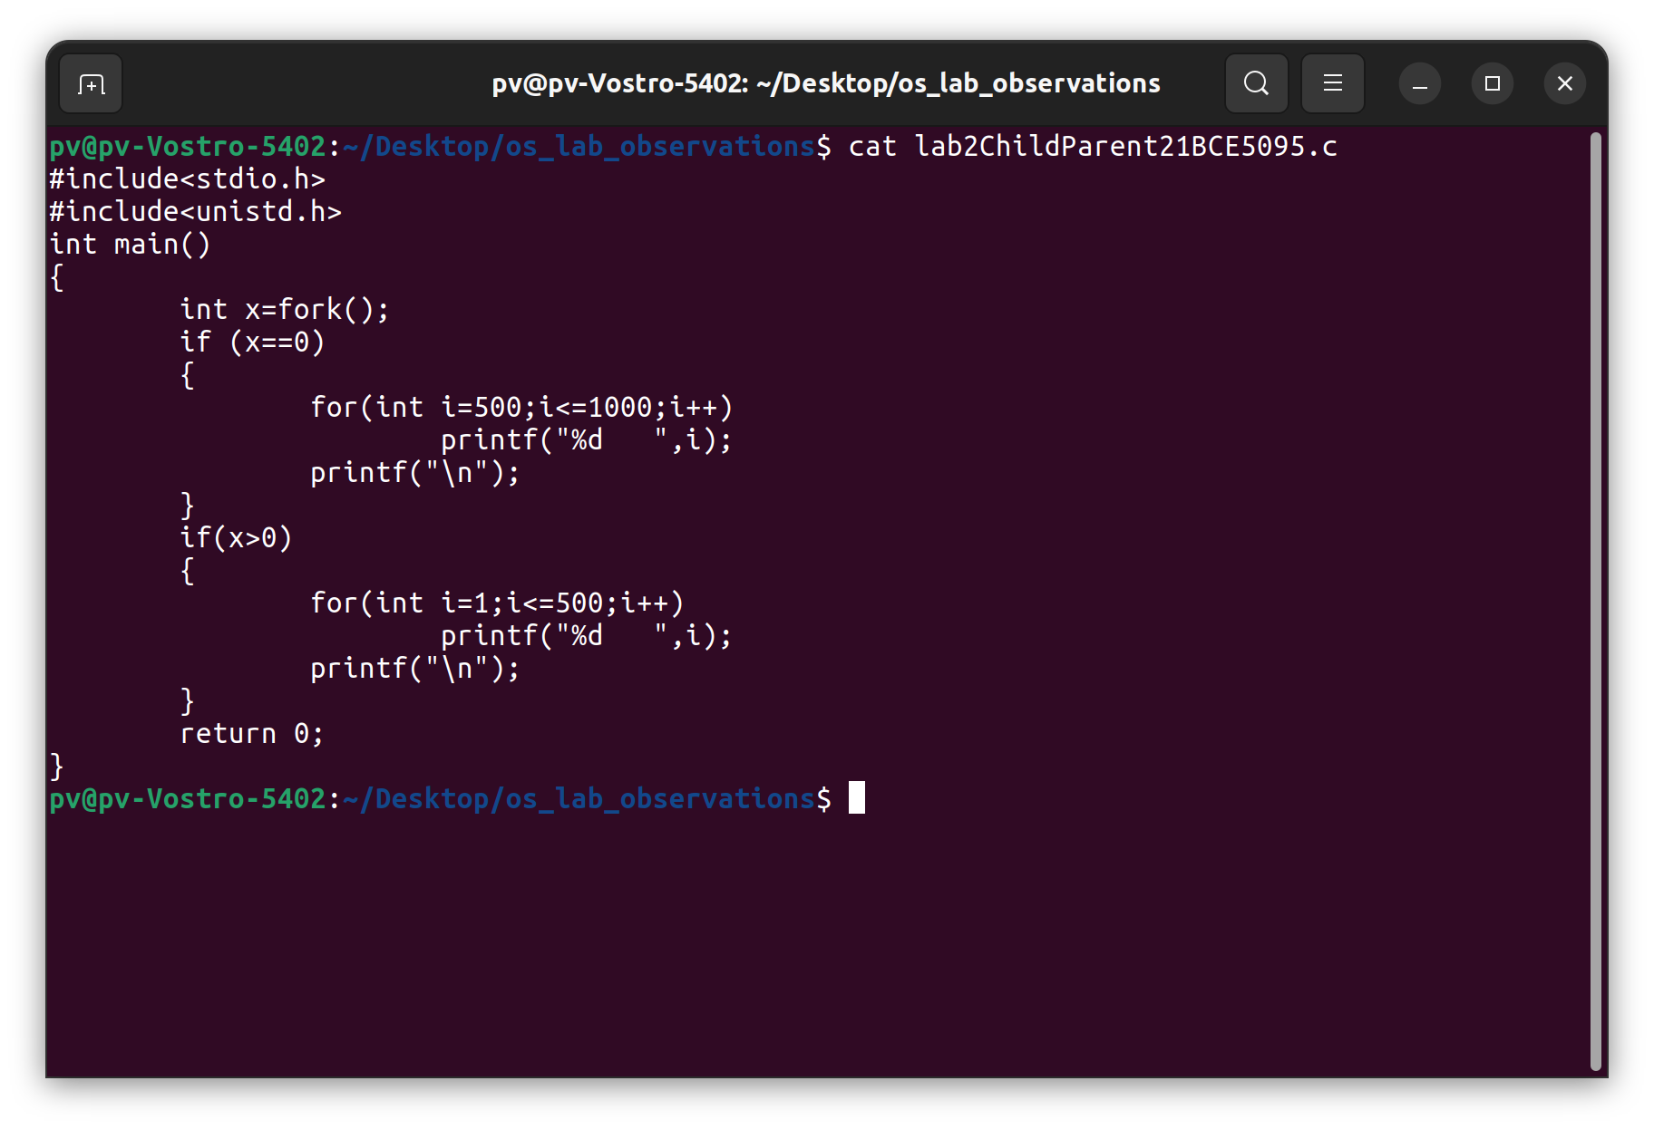Here the parent process is done first immediately after parent process done child process started doing its work

1. Show the code to create the Zombie and orphan processes with the explanation of how zombie process differs from orphan process.
   1. **Zombie process:**
      1. In this child process is done with it work and waiting for the parent, but at that moment parent was unable to kill that child process. So that child process here becomes zombie process.

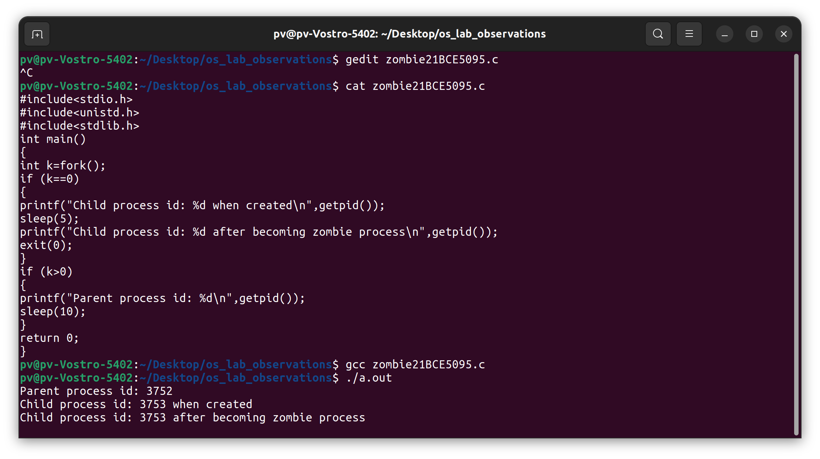

* 1. **Orphan Process:**
     1. In this parent process completes it work and exits, but still the child process is doing the work so there will no one active to kill that child process at the end so it becomes 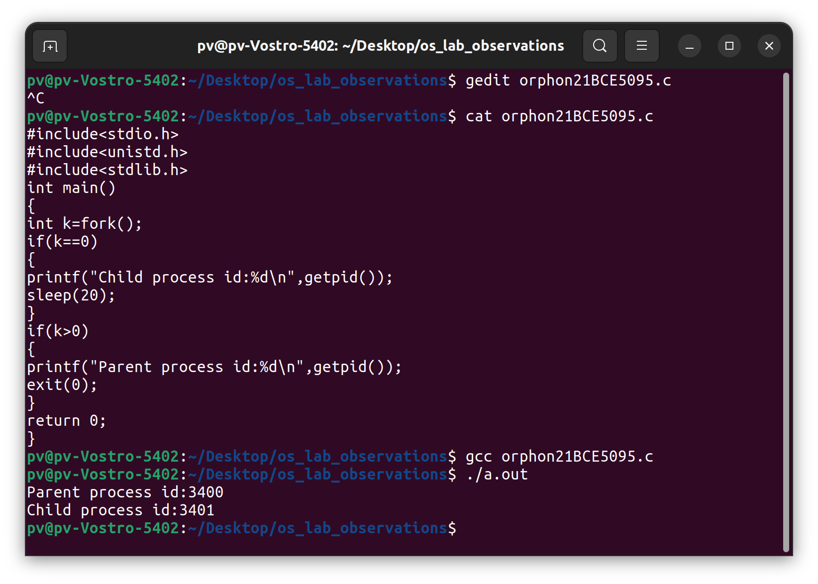orphan process.

1. 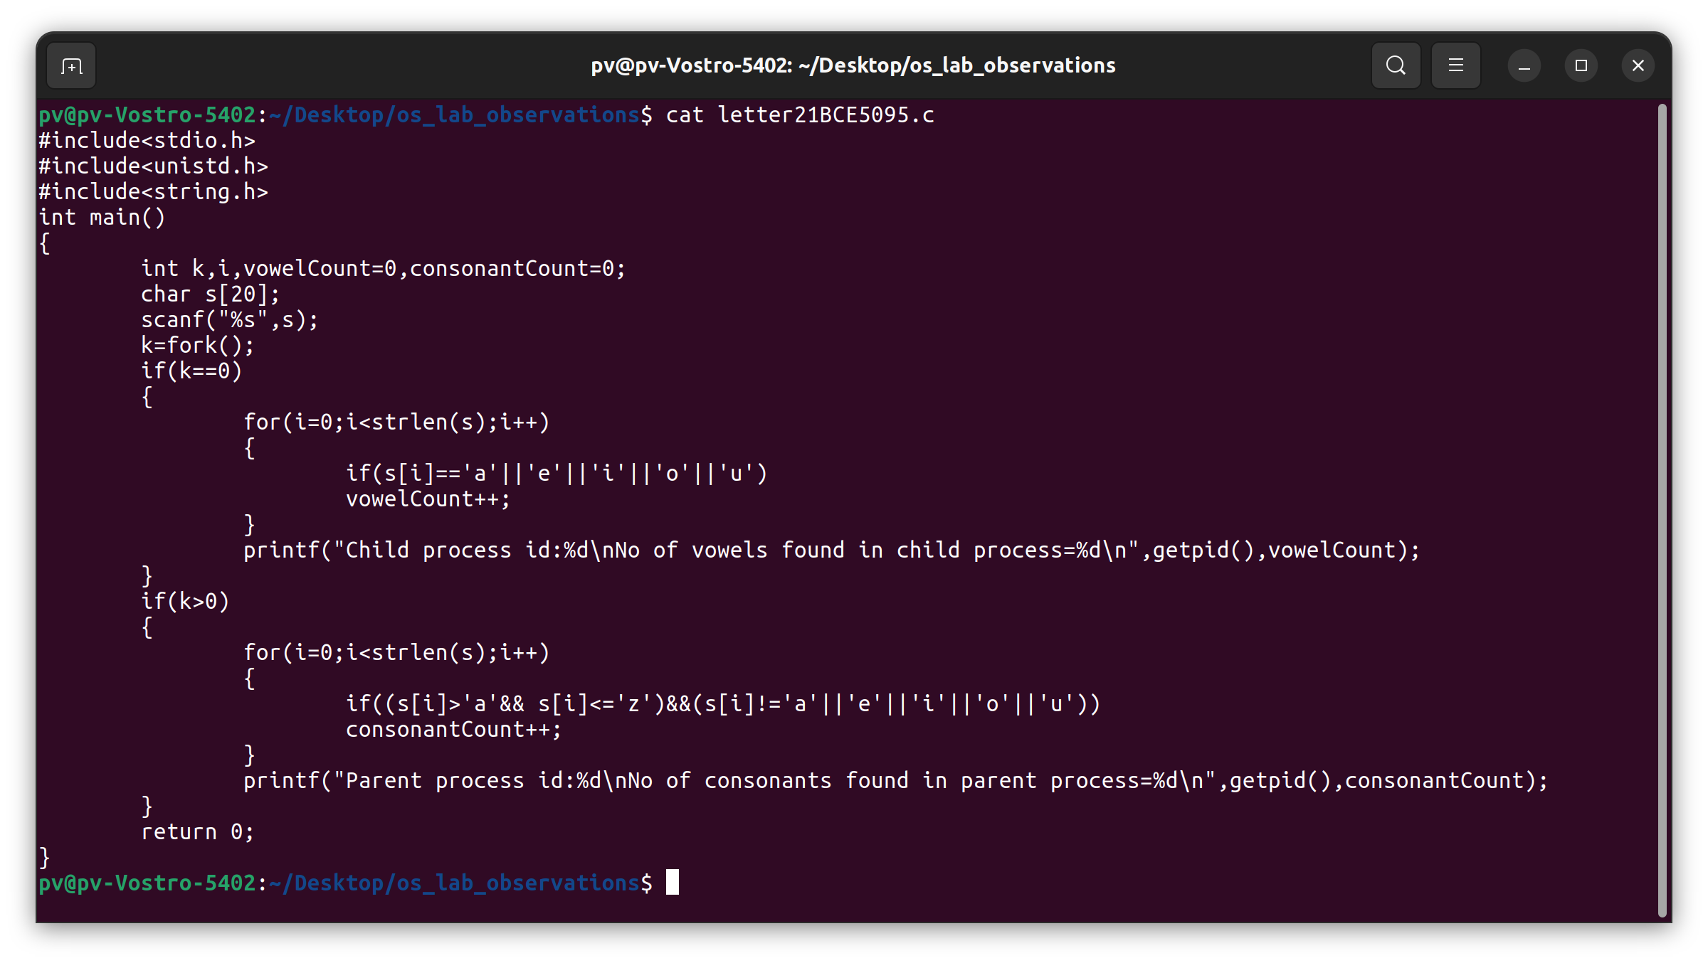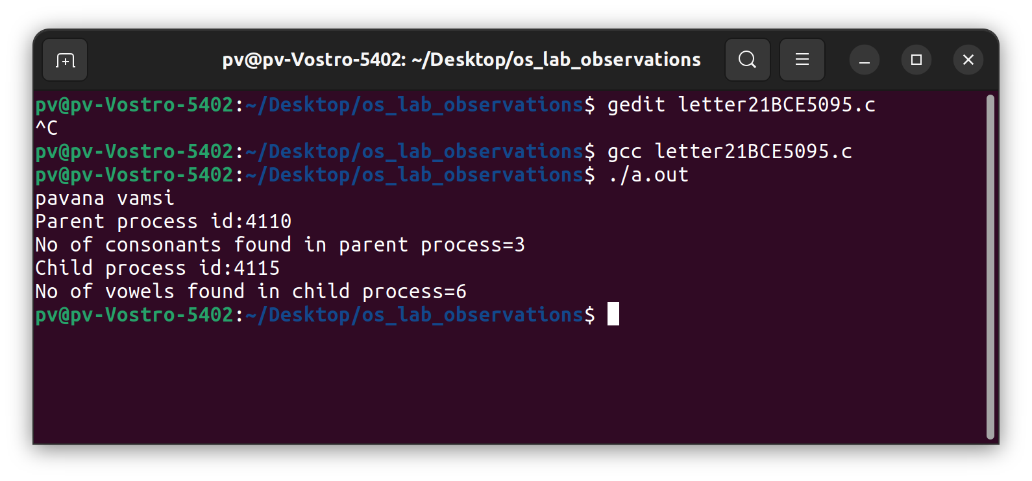Develop a child process and parent process to count the vowels and consonants accordingly of the given string and display the output.

1. 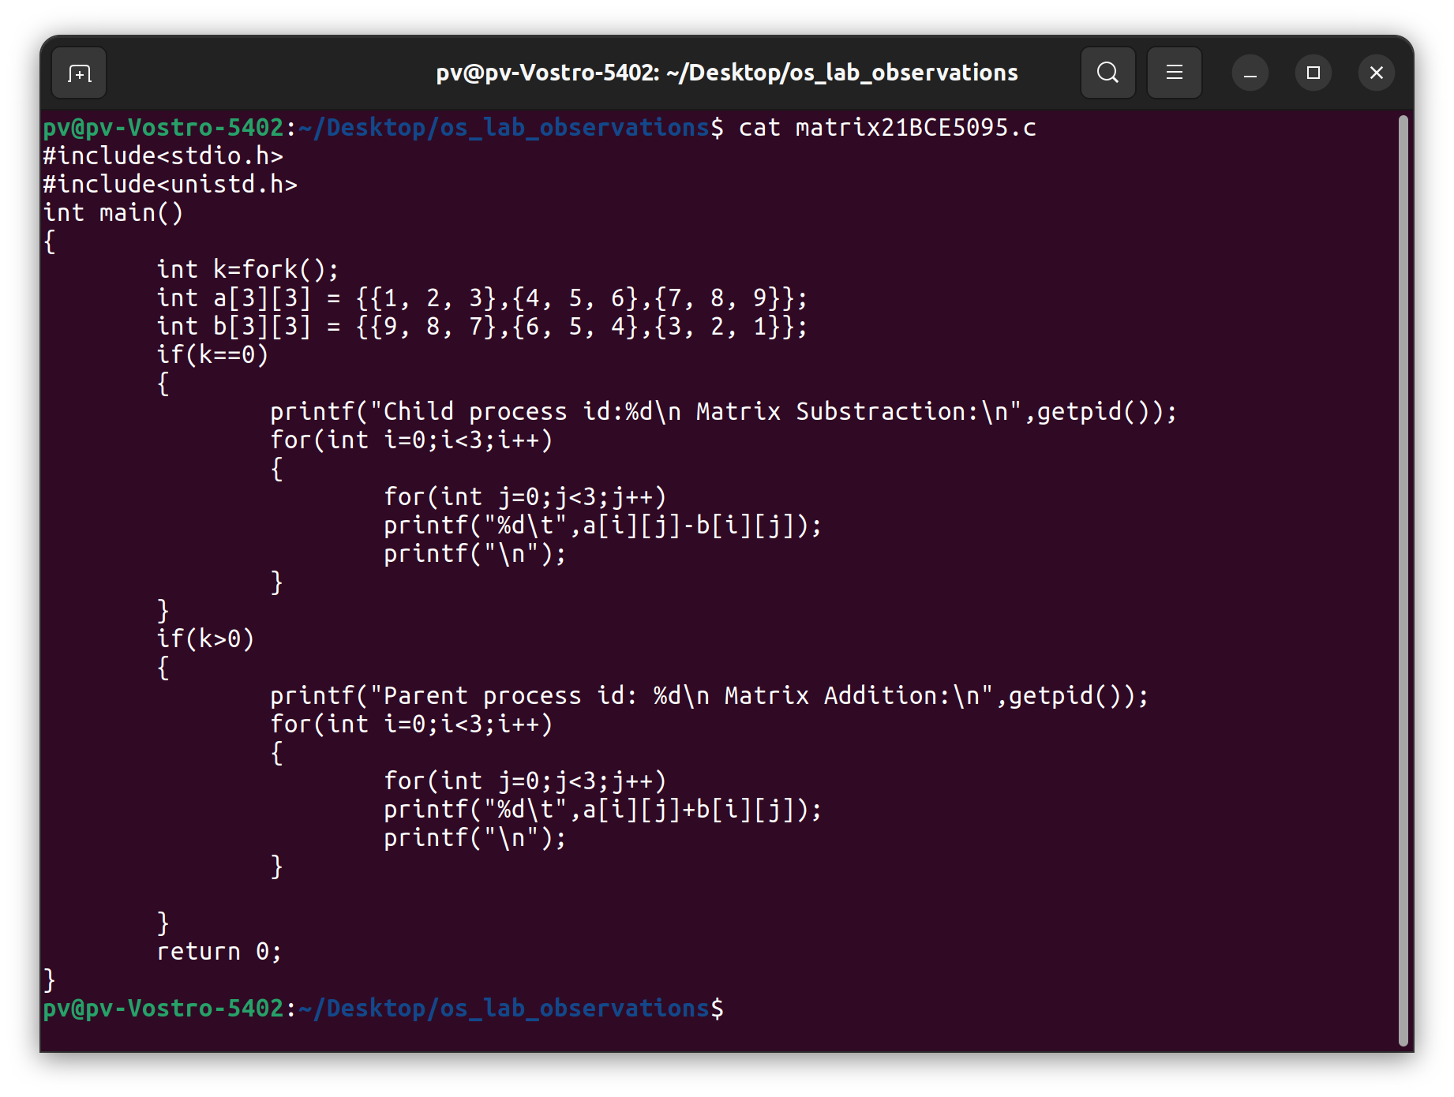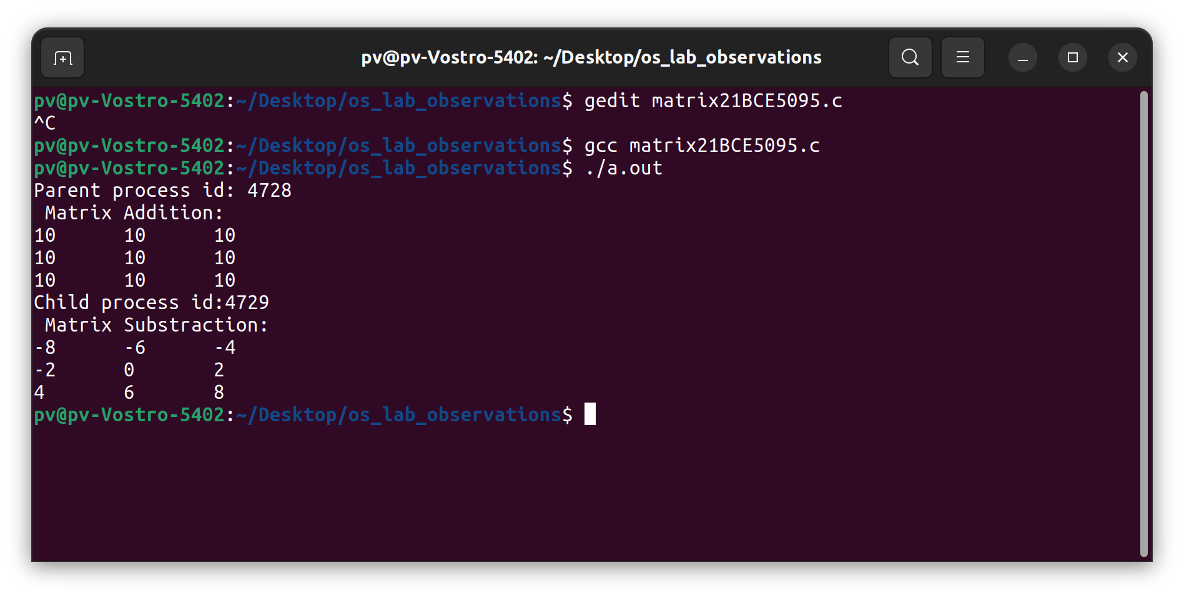Develop a child process and parent process to perform the matrix addition (by parent process) and matrix subtraction (by child process)
2. Develop 3 child processes for doing the below tasks  
   Child process 1- check the given number is even or odd  
   Child process 2 - Check whether the given number is prime or not  
   Child process 3 - Check whether the given number is divisible by 7 or not.

